**Sehhtye App**

Project Name: **Sehhtye App**

Idea:

It is a website that is interested in gaining weight, as it provides a set of health tips, a set of vitamins that the body needs, and a set of healthy recipes.

Used technologies :

Browsers: Google Chrome ,Internet Explorer.

Html

CSS

Flask

Last Code:

https://github.com/MaremarSamara/SehhtyApp.git

Diagram:

Use Case:

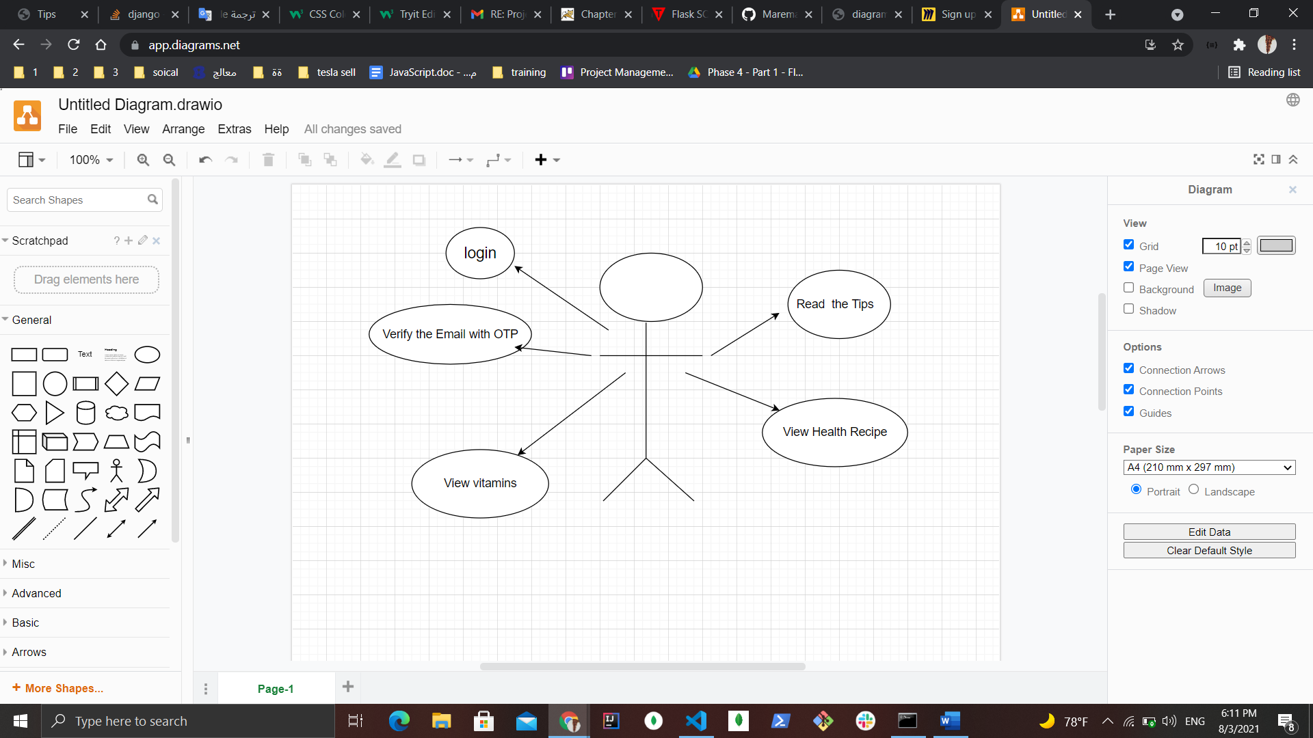

Flow chart diagram:

